Assignment – 7

# B.Rithwik

# 2303A52330

# Batch – 35

**Question - 1**

from google.colab import drive

drive.mount('/content/drive')

import pandas as pd

import matplotlib.pyplot as plt

from sklearn.linear_model import LinearRegression

data = pd.read_csv("/content/drive/MyDrive/SML Dataset/Salary_Data.csv")

X = data[['YearsExperience']]

y = data['Salary']

model = LinearRegression()

model.fit(X, y)

y_pred = model.predict(X)

plt.scatter(X, y, color='blue', label='Actual data')

plt.plot(X, y_pred, color='red', label='Best fit line')

plt.title('Years of Experience vs Salary')

plt.xlabel('Years of Experience')

plt.ylabel('Salary')

plt.legend()

plt.grid(True)

plt.show()

**OUTPUT –**

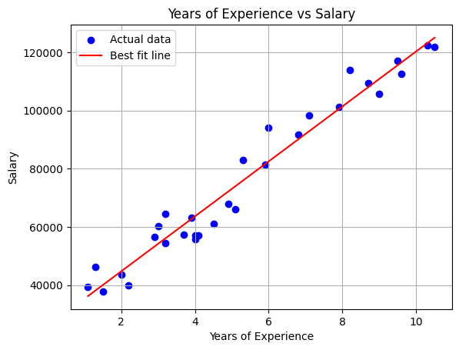

**Question – 2**

from google.colab import drive

drive.mount('/content/drive')

import pandas as pd

import matplotlib.pyplot as plt

from sklearn.linear_model import LinearRegression

data = pd.read_csv("/content/drive/MyDrive/SML Dataset/Assignment_7.csv")

X = data[['Feature 1']]

y = data['Target (Y)']

print(data)

data.head()

model = LinearRegression()

model.fit(X, y)

y_pred = model.predict(X)

plt.scatter(X, y, color='blue', label='Actual data')

plt.plot(X, y_pred, color='red', label='Best fit line')

plt.title('Feature 1 vs Target (Y)')

plt.xlabel('Feature 1')

plt.ylabel('Target (Y)')

plt.legend()

plt.grid(True)

plt.show()

**OUTPUT -**

**Feature 1 Feature 2 Feature 3 Feature 4 Target (Y)**

**0 1.2 2.3 3.1 4.2 15.6**

**1 2.4 1.9 2.8 3.5 13.1**

**2 3.5 2.7 1.5 2.9 12.4**

**3 4.1 3.0 3.6 4.8 18.2**

**4 1.9 2.8 2.5 3.2 14.1**

**5 3.7 2.5 1.9 4.0 16.0**

**6 2.1 3.2 2.2 4.1 14.5**

**7 3.3 2.4 3.0 4.5 17.3**

**8 2.8 3.1 1.8 3.6 14.9**

**9 4.0 3.3 2.7 4.9 19.2**

